2024 CRAPPIE TOURNAMENT SUMMARY

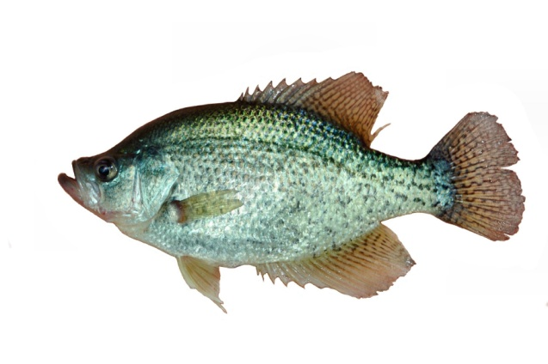

FISHERIES BUREAU

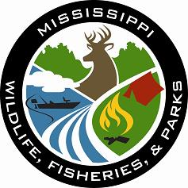

MISSISSIPPI WILDLIFE, FISHERIES, AND PARKS

1505 Eastover Drive

Jackson, MS 39211

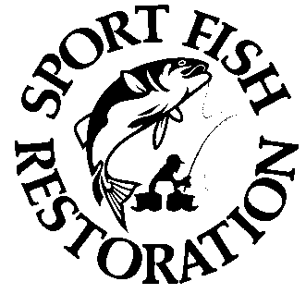

Your purchase of fishing equipment and motor boat fuels supports

Sport Fish Restoration and boating access facilities.

In 2011, Mississippi Department of Wildlife, Fisheries, and Parks (MDWFP) biologists started archiving results from crappie tournaments statewide. These data provide long term trends that help MDWFP manage one of our most popular sport fish, as well as offer insights for all crappie anglers about what kind of fishing to expect at different lakes.

A “tournament” was identified as such if daily results (or pro and amateur divisions) were reported separately or combined; ex. a two-day event with both days’ results combined was one tournament. Most events were one day, and teams were one or two anglers. Hours fished per event varied but were standardized to an 8-hour day for comparisons.

The hours required to catch a 2 lbs. or larger crappie is “N2”. Like golf, a lower N2 score is better. If no fish > 2 lbs. were caught in an event, N2 was assigned a value of 1000 hours, which was averaged with other N2 values for that lake.

Daily limits and formats of national crappie tournament trails have evolved in recent years, but in 2024 all national trails had 5-fish daily limits. Club events had either 5-fish or 7-fish daily limits. Results were obtained from thirteen 5-fish and eleven 7-fish tournaments at eight lakes (none from the Tennessee-Tombigbee Waterway).

Lower daily limits reduce tournament mortality, but comparing data from different daily limits was challenging. Average fish weight, average big fish weight, and N2 should be independent of daily limits and were compared for all events. Pounds and numbers of fish caught per day and daily winning weights obviously differed between 7- and 5-fish limits. The most notable findings in 2024 were:

* A total of 1,528 crappie anglers fished 13,188.5 hours. Grenada had seven reported tournaments, 29% of all events. Other lakes had one to six events. Anglers know there are good and bad fishing days - lakes with few tournaments may not accurately reflect the quality of those fisheries.
* Most tournaments were in spring and fall (Figure 1), but 29% were in summer (June – September). Summer events often have high crappie mortality.

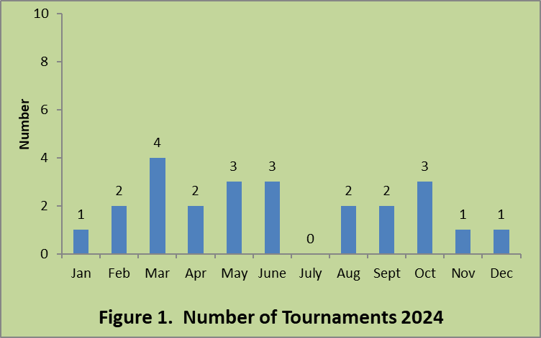

* Comparable metrics (7- and 5-fish events combined, Table 1) had mixed results. Average crappie weight was similar in 2023 and 2024, but average big fish declined by about 0.1 lbs. in 2024. It took 55 more hours (39% increase) to catch a crappie > 2 lbs. in 2024 than 2023, despite use of live sonar technology.

|  |  |
| --- | --- |
| **Table 1. Statewide Tournament Statistics** | |
| **2023 - 2024** |  |
| **1.63 - 1.66** | **Average weight of crappie kept (pounds)** |
| **141 - 196** | **Hours to catch a two-pound crappie (N2)** |
| **2.69 - 2.60** | **Average weight of biggest crappie (pounds)** |

* The average crappie weight ranged from 2.02 lbs. at Washington to 0.96 lbs. at Wolf (Figure 2). Similarly, N2 was lowest at Washington (7 hrs.) and highest at Wolf (Figure 2, none caught). The average big crappie from all events on each lake ranged from 2.90 lbs. at Washington to 1.52 lbs. at Wolf (Figure 2). Both Washington and Wolf had just one event, so their results may not be representative.

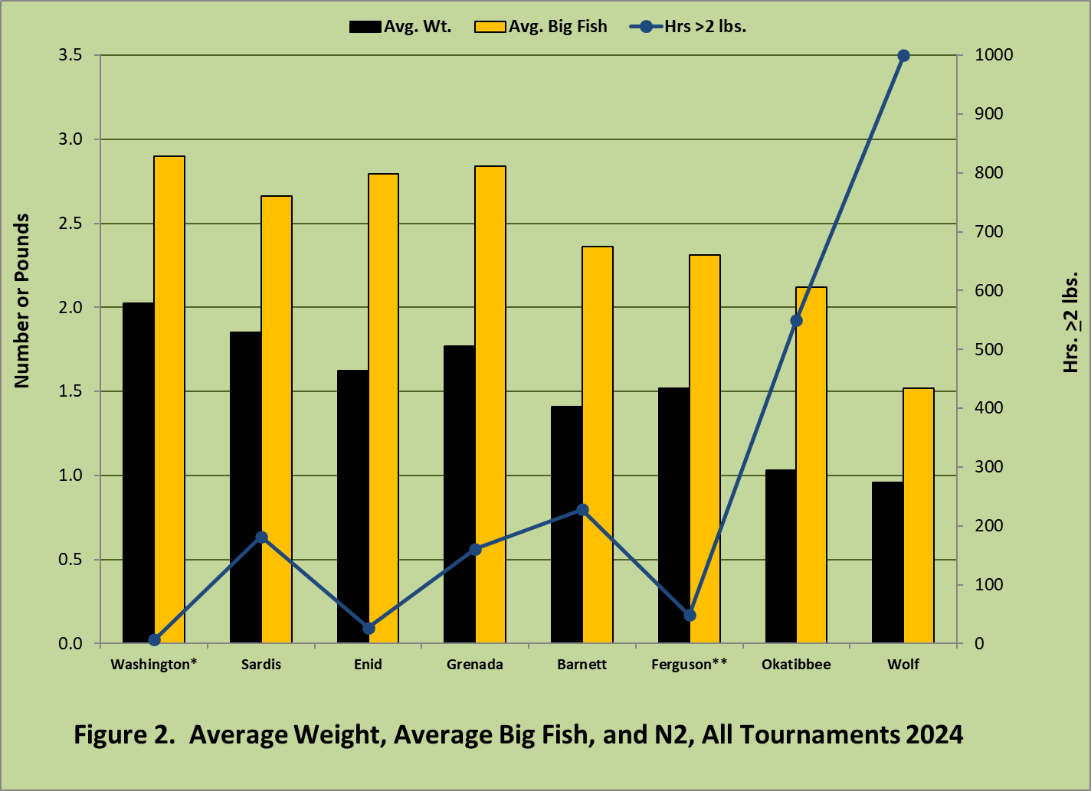

*Washington, Ferguson, Lee, Whittington **Ferguson, Chicot (AR), Lee

* The top 10 big fish came from 4 lakes (Table 2); 70% of these fish were caught in spring. With the growing popularity of live sonar, these statistics will be watched carefully for trends.

|  |  |  |  |
| --- | --- | --- | --- |
| **Table 2. Top 10 Heaviest Daily Big Fish Weights from 2024.** | | | |
| **Lake** | **Date** | **Tournament** | **Big Fish**  **Weight (lbs.)** |
| **Grenada** | **March 11** | **Crappie Masters** | **3.45** |
| **Grenada** | **August 17** | **Big 4 Crappie Club** | **3.32** |
| **Sardis** | **February 24** | **Magnolia Crappie Club NNational sters Trails** | **3.12** |
| **Grenada** | **October 18** | **National Crappie League** | **3.11** |
| **Enid** | **April 27** | **Big 4 Crappie Club** | **3.04** |
| **Sardis** | **September 21** | **Big 4 Crappie Club** | **2.94** |
| **Washington** | **March 4** | **National Crappie League** | **2.90** |
| **Grenada** | **April 6** | **Magnolia Crappie Club** | **2.81** |
| **Sardis** | **March 2** | **Big 4 Crappie Club** | **2.80** |
| **Grenada** | **May 24** | **Big 4 Crappie Club** | **2.78** |

* The heaviest daily limits also came from four lakes (Tables 3 and 4). Most of the top 5 heaviest 7-fish limits came from Barnett, but Grenada topped both lists. All the heaviest daily limits were caught in winter or spring. No lake came close to a daily limit averaging > 3 lbs. as was seen in 2022.

|  |  |  |  |
| --- | --- | --- | --- |
| **Table 3. Top 5 Heaviest Daily 7-Fish Limits, 2024**. | | | |
| **Lake** | **Date** | **Tournament** | **Daily 1st Place Weight (lbs.)** |
| **Grenada** | **April 6** | **Magnolia Crappie Club Masters** | **17.00** |
| **Sardis Grenada** | **February 24** | **Magnolia Crappie Club** | **16.57** |
| **Barnett** | **January 27** | **Magnolia Crappie Club** | **16.17** |
| **Barnett** | **December 14** | **Magnolia Crappie Club** | **16.05** |
| **Barnett** | **May 11** | **Magnolia Crappie Club** | **15.40** |

|  |  |  |  |
| --- | --- | --- | --- |
| **Table 4. Top 5 Heaviest Daily 5-Fish Limits, 2024**. | | | |
| **Lake** | **Date** | **Tournament** | **Daily 1st Place Weight (lbs.)** |
| **Grenada** | **March 9** | **Crappie Masters** | **14.08** |
| **Grenada** | **March 8** | **Crappie Masters** | **13.84** |
| **Washington** | **March 4** | **National Crappie League** | **13.23** |
| **Sardis** | **March 2** | **Big 4 Crappie Club** | **12.51** |
| **Sardis** | **February 17** | **Big 4 Crappie Club** | **12.33** |

* In 2024 (and past years) most crappie tournament sites were flood control lakes or oxbow lakes. During high water, these fish populations naturally expand; with low water, they contract. High water scatters fish and lowers fishing pressure (angler hours per surface acre). Low water concentrates fish for harvest and raises fishing pressure. These changes make separating environmental and harvest effects over time difficult.
* Most 7-fish metrics peaked in 2022 (Table 5) after several high-water years (2018 – 2021) on flood control and other lakes. There was a “lag” in some metrics as fish from flood year classes grew to larger sizes. Declining metrics, such as higher N2, since 2022 reflect both environmental (lower water levels) and harvest effects.

|  |  |  |  |  |  |  |
| --- | --- | --- | --- | --- | --- | --- |
| **Table 5. All metrics, Daily 7-Fish Limits, 2020 - 2024**. | | | | | | |
| **Year** | **N2** | **Daily Weight First** | **Avg Big Fish** | **Avg wt** | **Fish/Day** | **Lbs/Day** |
| **2019** | **153** | **14.07** | **2.62** | **1.54** | **2.85** | **4.18** |
| **2020** | **241** | **13.37** | **2.52** | **1.44** | **2.62** | **2.71** |
| **2021** | **186** | **14.75** | **2.61** | **1.65** | **2.66** | **4.27** |
| **2022** | **79** | **15.60** | **2.82** | **1.68** | **3.45** | **5.68** |
| **2023** | **118** | **14.98** | **2.70** | **1.62** | **3.71** | **6.59** |
| **2024** | **219** | **14.27** | **2.42** | **1.47** | **3.32** | **4.92** |

* For 7-fish 2024 events, Barnett had the highest average daily winning weight, but Sardis had the highest numbers and pounds per day (Figure 3, Table 6). Sardis ranked first in four of six metrics and first overall (Table 6). Grenada remained the best chance to land a crappie > 2 lbs. and ranked second in three metrics and second overall (Table 6). Wolf ranked last in all metrics (Figure 3, Table 6).

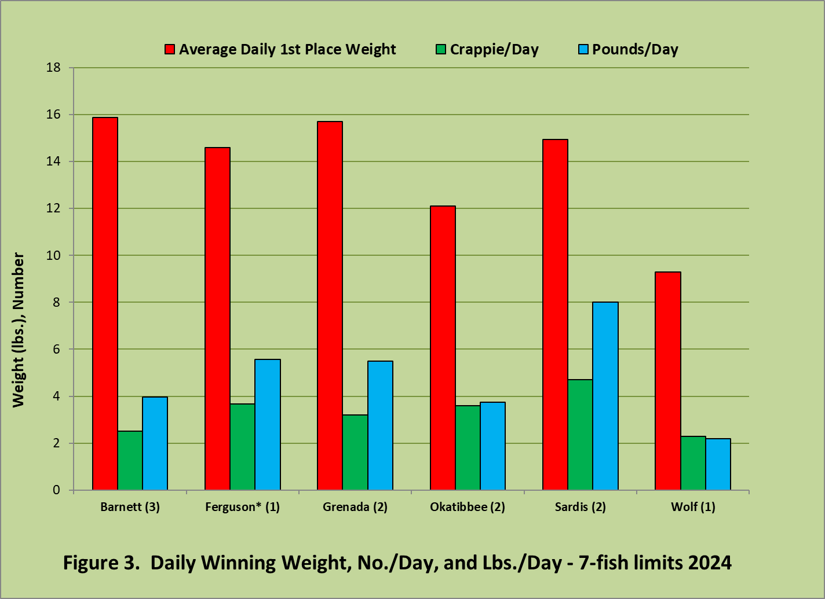

(number of events) *Ferguson, Chicot (AR), Lee

* For 5-fish events, Washington ranked first in three metrics and first overall (Figure 4, Table 7). Barnett ranked first in numbers and pounds per day and second overall (Figure 4, Table 7). Sardis and Grenada ranked low because both had summer events where no fish > 2 lbs. were caught.

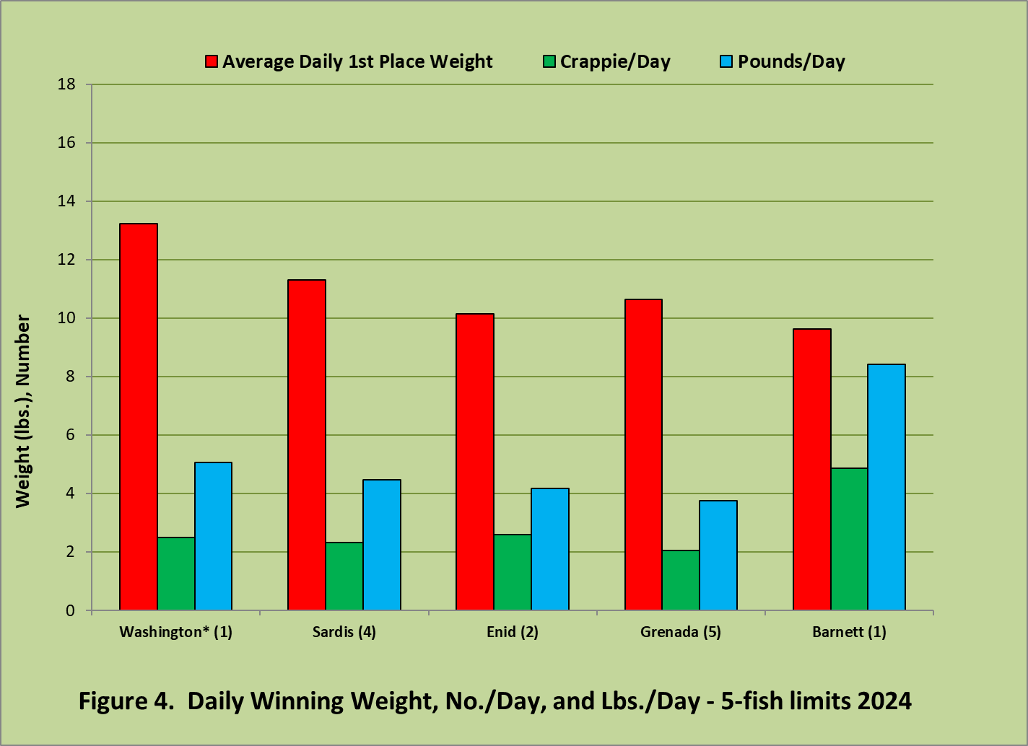

(number of events) *Washington, Ferguson, Lee, Whittington

* With different daily limits, numbers of events per lake, and seasons when events were held, it was impossible to rank a “best” lake. For example, Grenada ranked second in 7-fish events (Table 6), but last in 5-fish events (Table 7). “Best” is also subjective depending on anglers’ desires (ex. big fish versus numbers, etc.).
* Comparing rankings and metrics (Tables 6 and 7), Washington and Grenada looked good for big fish, but not numbers. Barnett and Sardis ranked well for both size and numbers. Wolf and Okatibbee had small fish, but Okatibbee had more of them. Other lakes were in between the extremes.

Consistent daily limits and more reported events would allow MDWFP to better monitor and compare Mississippi’s crappie fisheries. Detecting trends in these fisheries becomes more critical as angling technology improves, non-native species invade, habitat declines, public access is lost, anglers concentrate on fewer lakes, and the cumulative impact on the resource grows.

Despite it all, Mississippi’s crappie fishing remains good. Compared to bass fisheries (relative to their respective world record weights), a state average 2.42-pound big fish (white crappie) would equal a 10.38-pound largemouth bass. A state average 10.86-pound, 5-crappie limit would equal a 46.58-pound, 5-bass limit (a 9.32-pound average).

Since tournament limits are culled to the largest five or seven fish, their results differ from the catches of average crappie anglers. Tournament results and trends augment data from other MDWFP surveys (creel, electrofishing, netting, etc.) used to evaluate, monitor, and manage Mississippi’s nationally acclaimed crappie fisheries. It also can be utilized by other biologists, average crappie anglers, and tournament organizations to improve crappie management, increase angling success, and maximize tournament success and/or participation.

Acknowledgements: Results were obtained from websites and/or Facebook pages of Crappie Masters and National Crappie League national tournament trails, the Magnolia Crappie Club, PTG Outdoors, and the Big 4 Crappie Club. Many thanks to these organizations for their prompt and complete postings of tournament results.

Without anglers’ help, MDWFP’s ability to evaluate your fisheries is reduced. Tournament organizers that want to participate directly in next year’s Crappie Tournament Summary can email their 2025 tournament results to either:

Keith Meals [keith.meals@wfp.ms.gov](mailto:keith.meals@wfp.ms.gov) , Arthur Dunn [Arthur.Dunn@wfp.ms.gov](mailto:Arthur.Dunn@wfp.ms.gov) , or Katy Wilson [katelyn.wilson@wfp.ms.gov](mailto:katelyn.wilson@wfp.ms.gov)

Table 6. Final rankings of 7-fish crappie tournament lakes in Mississippi based on 2024 results.

|  |  |  |  |  |  |  |
| --- | --- | --- | --- | --- | --- | --- |
| **Overall Rank** | **Hours to catch a crappie > 2 lbs.** | **Average daily**  **1st place weight (lbs.)** | **Average**  **Lunker (lbs.)** | **Average weight**  **(lbs.) of fish** | **Average number of crappie per angler**  **per day** | **Average lbs. per angler per day** |
|  |  |  |  |  |  |  |
| #1 Sardis (2) | Grenada 25 | Barnett 15.87 | Sardis 2.81 | Sardis 1.75 | Sardis 4.70 | Sardis 8.01 |
| #2 Grenada (2) | Sardis 28 | Grenada 15.71 | Grenada 2.63 | Grenada 1.72 | Ferguson 3.67 | Ferguson 5.57 |
| #3 Ferguson* (1) | Ferguson 48 | Sardis 14.94 | Barnett 2.59 | Barnett 1.56 | Okatibbee 3.60 | Grenada 5.50 |
| #4 Barnett (3) | Barnett 52 | Ferguson 14.59 | Ferguson 2.31 | Ferguson 1.52 | Grenada 3.21 | Barnett 3.97 |
| #5 Okatibbee (2) | Okatibbee 550 | Okatibbee 12.11 | Okatibbee 2.12 | Okatibbee 1.03 | Barnett 2.50 | Okatibbee 3.75 |
| #6 Wolf (1) | Wolf 1000 | Wolf 9.28 | Wolf 1.52 | Wolf 0.96 | Wolf 2.28 | Wolf 2.19 |

Number of 7-fish tournaments in parentheses. * Lakes Ferguson, Lee, and Chicot (AR).

Table 7. Final rankings of 5-fish crappie tournament lakes in Mississippi based on 2023 results.

|  |  |  |  |  |  |  |
| --- | --- | --- | --- | --- | --- | --- |
| **Overall Rank** | **Hours to catch a crappie > 2 lbs.** | **Average daily**  **1st place weight (lbs.)** | **Average**  **Lunker (lbs.)** | **Average weight**  **(lbs.) of fish** | **Average number of crappie per angler**  **per day** | **Average lbs. per angler per day** |
|  |  |  |  |  |  |  |
| #1 Washington* (1) | Washington 7 | Washington 13.23 | Grenada 2.92 | Washington 2.02 | Barnett 4.86 | Barnett 8.41 |
| #2 Barnett (1) | Enid 27 | Sardis 11.31 | Washington 2.90 | Sardis 1.90 | Enid 2.58 | Washington 5.06 |
| #3 Sardis (4) | Barnett 112 | Grenada 10.64 | Enid 2.80 | Grenada 1.79 | Washington 2.50 | Sardis 4.46 |
| #3 Enid (2) | Grenada 215 | Enid 10.15 | Sardis 2.59 | Barnett 1.73 | Sardis 2.33 | Enid 4.18 |
| #4 Grenada (5) | Sardis 259 | Barnett 9.64 | Barnett 2.21 | Enid 1.62 | Grenada 2.05 | Grenada 3.75 |

Number of 5-fish tournaments in parentheses. * Lakes Washington, Ferguson, Lee, and Whittington.

This page is intentionally left blank.